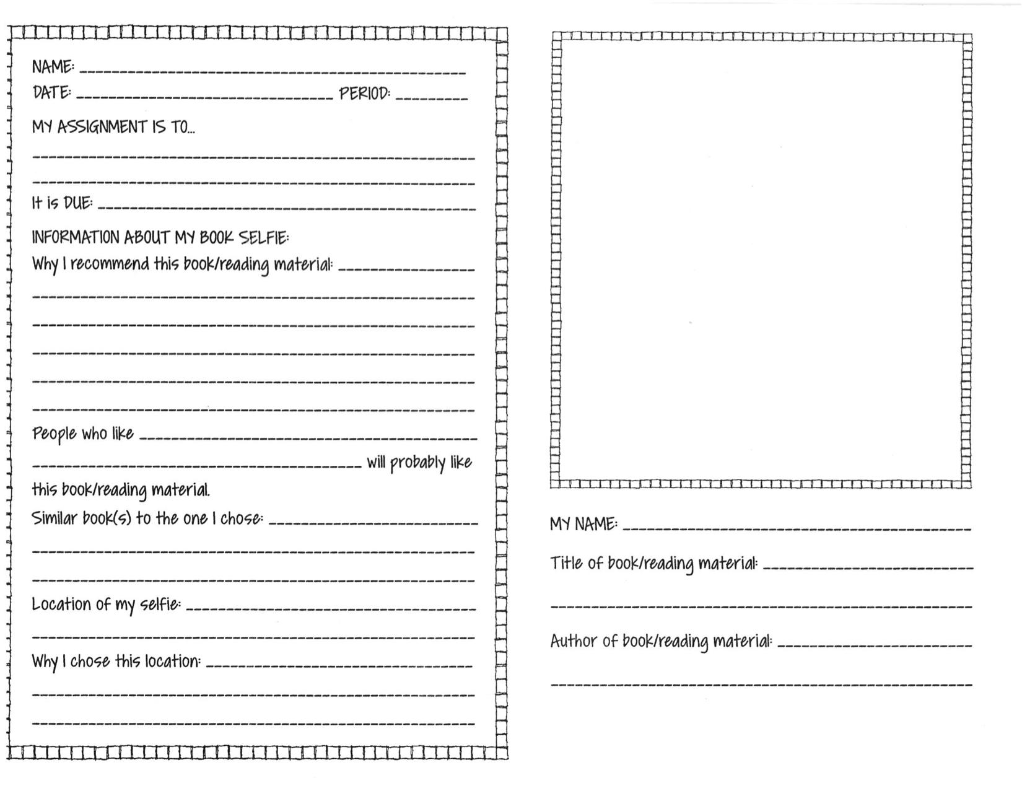
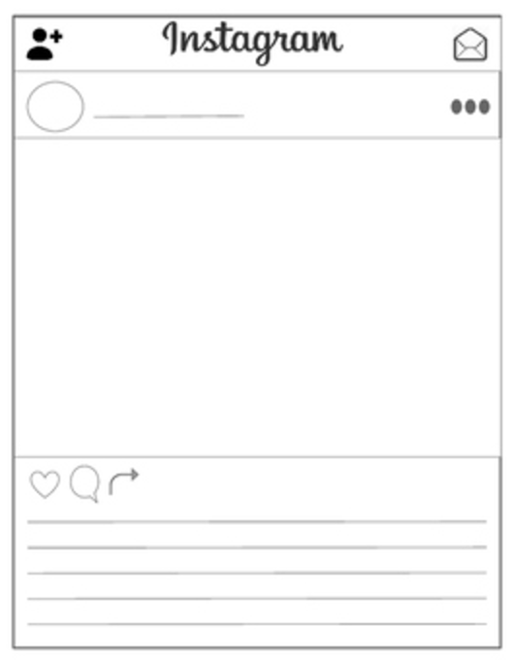

Instagram Book Post

You can choose to do this option instead of the book selfie!

Instructions:
- Create a sweet instagram handle and icon to identify yourself.

- you read most recently and glue it to the instagram template to the left.

- Write a short caption about the book you posted. It can be a simple summary of the story or your thoughts on the book. Don’t forget your hashtags! For example, if I had chosen Harry Potter I might say: “The magical world of Harry Potter invites the reader to feel like a kid again. #whereismyhogwartsletter #potterhead” or “Harry Potter, ‘The Boy Who Lived’ vanquishes Voldemort to protect the wizarding world and his friends at Hogwarts. #harrythehero #justakid”

- Cut out the template on the left, write your name on the back of it, and bring it back to class.

