MLA Formatting
Author’s last name, first name. Title. Place of publication: Publisher, year. Page number. Medium.
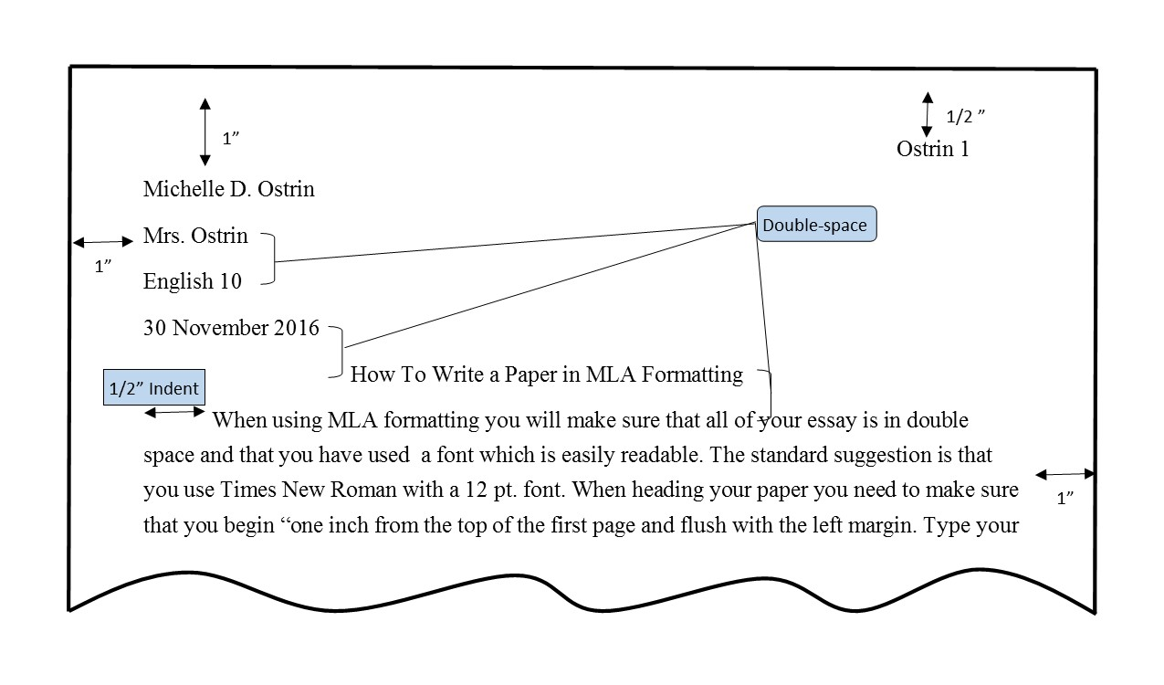
Example: Jans, Nick. The Last Light Breaking: Life among Alaska's Inupiat Eskimos. Alaska Northwest Books, 1993. Print
MLA Formatting
Author’s last name, first name. Title. Place of publication: Publisher, year. Page number. Medium.
Example: Jans, Nick. The Last Light Breaking: Life among Alaska's Inupiat Eskimos. Alaska Northwest Books, 1993. Print

