The Negative Effects of Fairy Tales

Why fairy tales do not teach the right lessons
by taragraetzel2 years ago9,590 Views

Fairy tales have been a staple in the entertainment of children for years and just about every child has been exposed to them at some point in their young lives. Parents read bedtime fairy tales to their kids all the time and children everywhere watch the Disney movies on repeat. All the little girls want to dress up like the pretty princesses, while all the boys act out heroic scenes from the movies. “Children played at those stories; they dreamed about them. They took them to heart and acted as if to live inside them” (Maguire).These fairy tales do teach some valuable lessons no doubt, such as do not trust strangers, be happy with who you are and do not judge a book by its cover. However, there are also some negative aspects of fairy tales. Although fairy tales may seem fun and innocent from the outside, they are teaching children false ideas about love, gender roles and concepts of good versus evil, which can lead to problems later on with extremely high expectations, depression, body image issues and an unreal look on life.
Every good fairy tale has a love story, if you could even call it an actual love story. They usually consist of a love at first sight situation, where the two characters fall head over heals for each other. The man usually commits some act of bravery for the princess, they share their first kiss and soon enough they have an extravagant wedding and live happily ever after. This is not anything close to how love works in the real world. People often date a lot of others, eventually find someone they love (or some end up settling unfortunately),get married, have kids and then hope that their marriage lasts. “Real relationships don’t involve knights in shining armor, soul mates, gleaming carriages, castles or, above all, living happily ever after. But the Disneyized tales now engraved in our consciousness make us feel these things are real” (Epstein). Fairy tales also seem to leave out a lot of the confusion and hardships that come along with love. The prince and princess never have any disagreements and absolutely never get in fights.Everything is always flowery and happy, which does not come close to representing a real relationship.
Fairy tales have blown our expectations of love completely out of reality and this can be dangerous to young, impressionable children who watch or listen to them thinking that things like this actually happen in real life. First of all, they can have children believing in love at first sight. There is absolutely no way you can simply look at someone and instantly fall in love with them. There is attraction, which can make you want to get to know the person, but you cannot fall in a true kind of love solely based on looks.
Fairy tales also turn love into a short process. A wedding comes along shortly after the two lovers meet and they are assumed to be happily ever after. It takes time for love to grow, but many people rush into it without much thought. This can be a contributing factor to the high divorce rate in society today with “nearly half of first marriages in the U.S. end[ing] in divorce, two-thirds of second marriages and three-quarters of third marriages” (Epstein). People who get divorces realize that they are not truly happy and have not found “the one” that fairy tales have insisted they search for. Fairy tales have instilled such high expectations of love that could not possibly ever be met, but some people still believe that they can be.
Stereotypical gender roles are also prevalent in fairy tales. The typical story involves a young woman in a terrible situation, whether it is poverty, an evil stepmother or being locked away in a tower. They are always completely miserable with their lives and hope daily for a man to come and rescue them. These women do not make an effort to make their own dreams happen and rely on a man to come fix their problems. Sure enough a beyond handsome and strong prince will come along and save them from their terrible lives. The prince and princess then get married and live as husband and wife.
With these gender roles it is no wonder why women believe their key to happiness is a man. Many women wait around for a man to come sweep them off their feet and make their life wonderful. “Most girls latch onto the myth of prince charming, a well groomed persona, preferably with a French accent, that is going to liberate them from all the evil spells!” (Jose). Women find themselves depending on men their entire lives instead of trying to be independent and in charge of their own happiness. When these women are not able to find a “Prince Charming” it can lead to depression because their lives are not just like the fairy tales. Ever since they were little girls they dreamed of falling in love and then when they are older and have yet to find someone it can make them depressed. This depression can last a long time because many people will feel like they lack the one thing that could make them happy and save them from their misery.
Another psychological issue that can occur is ““The Cinderella Complex,” or women’s unconscious fear of independence and desire to be taken care of by others” (Walleston). If a woman is unable to find a man to take care of her, she oftentimes looks for care from her parents or other family members. The Cinderella Complex is getting in the way of women actually living independent and successful lives. This only furthers a woman’s dependence on a man. Fairy tales have brainwashed us into thinking that you must get married to have a fulfilling life, when in reality “a young woman should have other dreams besides getting hitched” (Jose). Women should want to be able to take care of themselves and not depend on a husband for everything.
Another aspect of gender is how the characters are physically portrayed, especially in the movies. The women are always beautiful with perfect skin, flowing hair, big eyes, long legs, small hands and tiny waists. The men are always huge, tall, and muscular with
perfect hair and face structure. There is no such thing as an ugly princess or prince and they all look relatively similar.
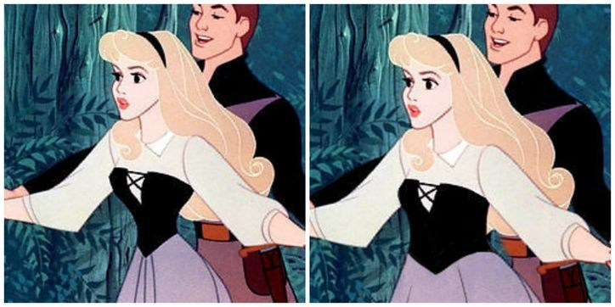
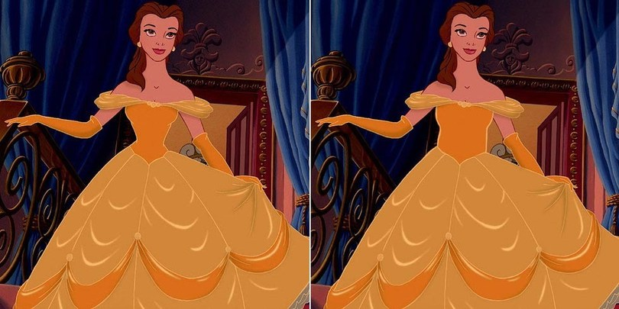
This can lead to body image issues where children grow up thinking they will never find true love because they do not look like the characters in the movies. Little girls grow up seeing how skinny the princesses are and thrive to look like that, even though if the animated characters were real people they would probably be too skinny to survive. “Some studies have suggested that girls who read a lot of fairy tales or [watch a lot of fairy tale related movies] have lower self images than others” (Danish). Boys may also feel the pressure to be buff and handsome in order to win the girl over, which is just as damaging.
There would not be a tale to be told if it were not for the villains. Fairy tales paint the struggle between good and evil in black and white. “You flip open a fairytale and you can pretty much figure out who is the “good guy” and who is the “bad guy”” because there is no in between (Schussler). From the very beginning of the story the reader or viewer is made to hate the villains through their words and actions. Villains are always portrayed as hideous people who “exemplify bad health habits: poor hygiene, gluttony, laziness, stress” and are usually fat (Walleston). These visions contrast with the beautiful “good” people of the story and make you hate them even more.
This portrayal of good versus evil does not transfer well into the real world and does not teach a very good lesson to children. The idea that there is only good and bad is completely wrong. Everyone has a little good and a little bad in them and this should not be overlooked. Good people can become bad over time, and bad people can be transformed into good. Fairy tales teach us to instantly hate the bad characters without any regard to what happened to that character in the past that makes them the way they are. Very rarely is the villain’s side of the story told and “ it can hinder the development of empathy. How can a child feel empathy towards an antagonist when all the child is exposed to is the side of the protagonist?” (Schussler). Fairy tales only teach us to hate those we are mean to us; they do not teach about forgiveness and how to become good again.
This brings us to the question of should people stop reading and showing fairy tales to children in the hopes of stopping these negative effects they can have on our lives? It is true that fairy tales can lead to problems later on with extremely high expectations of love, psychological effects such as depression and other complexes, body image issues and an unreal look on life. However, fairy tales can teach some moral lessons and are genuinely entertaining. Instead of completely cutting out fairy tales from childhood, parents should explain to their children that they do not properly demonstrate the real world and also teach their children not to idolize the princesses and princes. Fairy tale writers and movie makers should modify these fairy tales or write new ones that are more realistic with better morals.

Works Cited:
Danish, Elizabeth. "Influence of Fairy Tales on Children." Health Guidance. Web. 12 Feb. 2015.
Epstein, Robert. "How Walt Disney Ruined Our Love Lives." Brandeis Magazine 1974:
Brandeis Magazine. Web. 12 Feb. 2015.
Jose, Dina. "Fairy Tales are Grimm." The F Word. 11 Dec. 2006. Web. 12 Feb. 2015.
Maguire, Gregory. "Quotes about Fairytales." Good Reads. N.p., n.d. Web. 26 Feb. 2015.
Schussler, Arielle. "The Case Against Fairytales." Caliber 13 Mar. 2013: Web. 12 Feb. 2015.
Walleston, Kimberly. "Animation Contamination: Are Disney Films Giving Our Kids
Complexes?" Insiders Health. 2011. Web. 12 Feb.

